Eminent Association of Researches in Humanities & Management Sciences
Membership Form
www.EARHM.org

Please supply us with the following contact information:
FULL Name with Designation (e.g. Prof. / Dr./Assoc. Prof./ Asst. Prof./Lecturer) | Department Name, School/Institute/University Name, City & Country | Email ids separated with commas | Contact Number/Mobile Number* | Specialization/Areas of Interest | 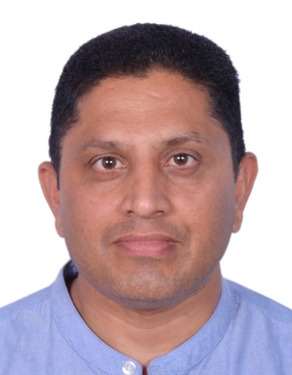
Dr. Varinder Singh Rana, Department Chair | Hospitality and Tourism Management, City University College of Ajman, Ajman, United Arab Emirates | r.varinder@cuca.ae | +971521099004  +919888816604 | Hospitality and Tourism
*kindly mention if the WhatsApp/Viber/line/Telegram facility is available on your number Yes

Please write agree or disagree as per your choice:
- I have no objection if my name is added in Program/Scientific Committees of Conferences of EARHM: (Agree/Disagree) __Agree_______________
- I am ready to act as reviewer of the papers/articles for Conferences of EARHM: (Agree/Disagree) ____Agree_____________
- I have NO OBJECTION if my name is added as EDITOR of the Conference Proceedings: (Agree/Disagree)________Agree_________
- I have NO OBJECTION if my Name and Photo is displayed as Emient Member on the conference website: (Agree/Disagree)___Agree___________
- I have no objection if my name is added in Reviewer Committees of Conferences of EARHM: (Agree/Disagree) Agree________________
All the above particulars correct and I agree with the conditions of membership as given above.

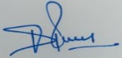 Dr. Varinder Singh Rana, September 28, 2022______________
Signature with Name & Date

Please Email this filled form in (word file with Signature) via e- mail to: cs@earhm.org
The membership is free. The grade of Senior Member is conferred to those who have made significant professional contribution in the relevant fields. The candidate must have doctorate degree/ equivalent from an accredited educational Institution. The person can directly get Senior Membership with relevant level of experience in the field. The Term of senior Membership is 3 years from the date of approval and in case of member the term is 1 year initially.

**Conditions-
The Membership is Free and any change in your Affiliation, Address, Email ID or Contact number should be informed to EARHM, well in advance, in a prescribed format.
In case EARHM contacts you then is requested to reply within 48-96 hours. If the EARHM Official is not able to reach you (or not getting appropriate response) at the given address then your membership may be cancelled without any notice. That to abide all the rules and regulations of the EARHM from time to time.

